HOW TO ACCESS PAY STATEMENTS ON ADP

Log into your ADP Self-Service Portal: https://workforcenow.adp.com/workforcenow/
On the HOME PAGE, Go to the Lower Left-hand corner of the page and Click on Pay Statements:
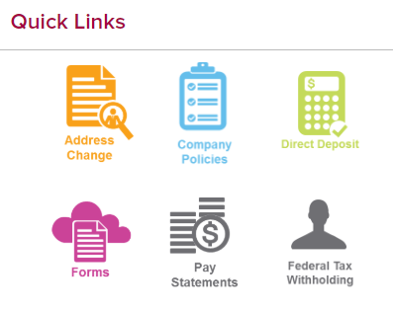
Select the Pay Statements Option:
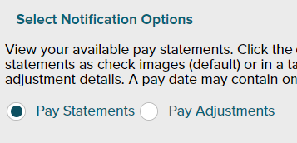
Scroll to the right to view pay statement going back to January 2019.
CLICK on View Check (make sure Pop-up Blockers are turned off) to view the Full Pay Statement for the chosen Pay Date:
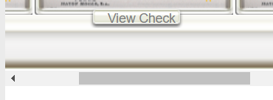
The Pay Statement can be Printed or saved as a PDF.

