Accessing W2s from ADP

You can access your W2 when you login to your ADP. Just type (w2) in the Search Workforce Now search box and select Annual Statements. It will direct you to a recorded yearly W2 and 1099 page. Just select the recent year you are needing.

Search (W2) & Select Annual Statements.
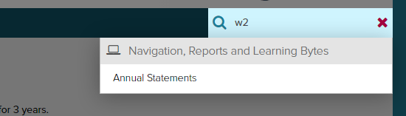

The most current year W2 will be the top “W2 – OZARKS REGIONAL YMCA” listed in the “Tax Statements” box on the right. Select the download icon and be prepared to receive and enter a security code.
